Chapter 6 MOOD DISORDERS AND SUICIDE
- This Web Exercise focuses upon suicide prevention and risk for our elder community members.

Please view The Suicide Prevention Resource Center (SPRC) Suicide Risk for Older Adults
http://www.sprc.org/video/reaching-older-adults

Discuss three aspects of the video that helped you understand the significance of suicide prevention and risk with our older community members. How might the knowledge you gained influence the future work you engage in?

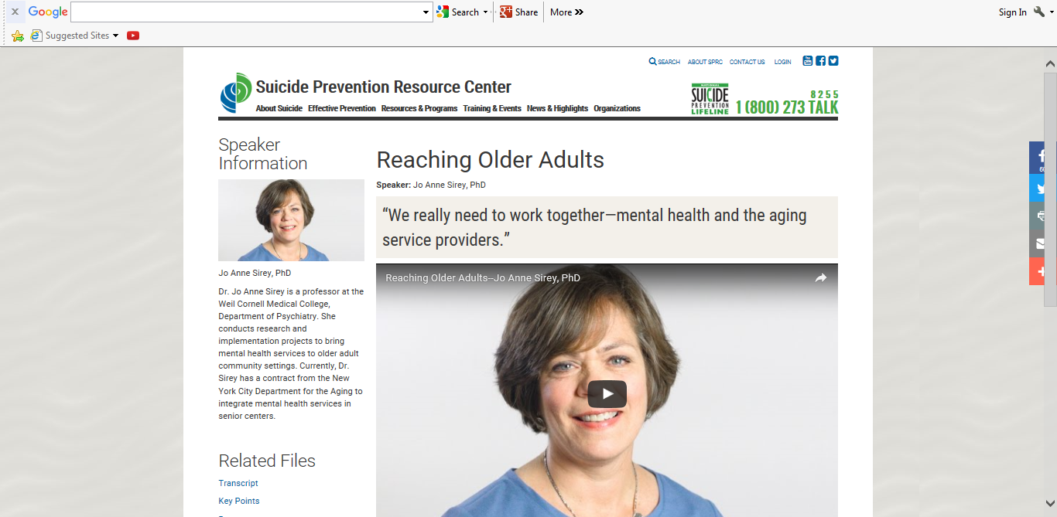

- This Web Exercise focuses upon suicide prevention and risk for men in our communities.

Please view The Suicide Prevention Resource Center (SPRC) Men in the Middle Years
http://www.sprc.org/video/men-middle-years

Discuss three aspects of the video that helped you understand the significance of suicide prevention and risk with for men our communities. How might the knowledge you gained influence the future work you engage in? What are the challenges in reducing suicide risk for men especially when they are less likely to seek therapeutic services? How do you think primary care physicians and health-care providers can better understand the suicide-risk of their male patients and clients?

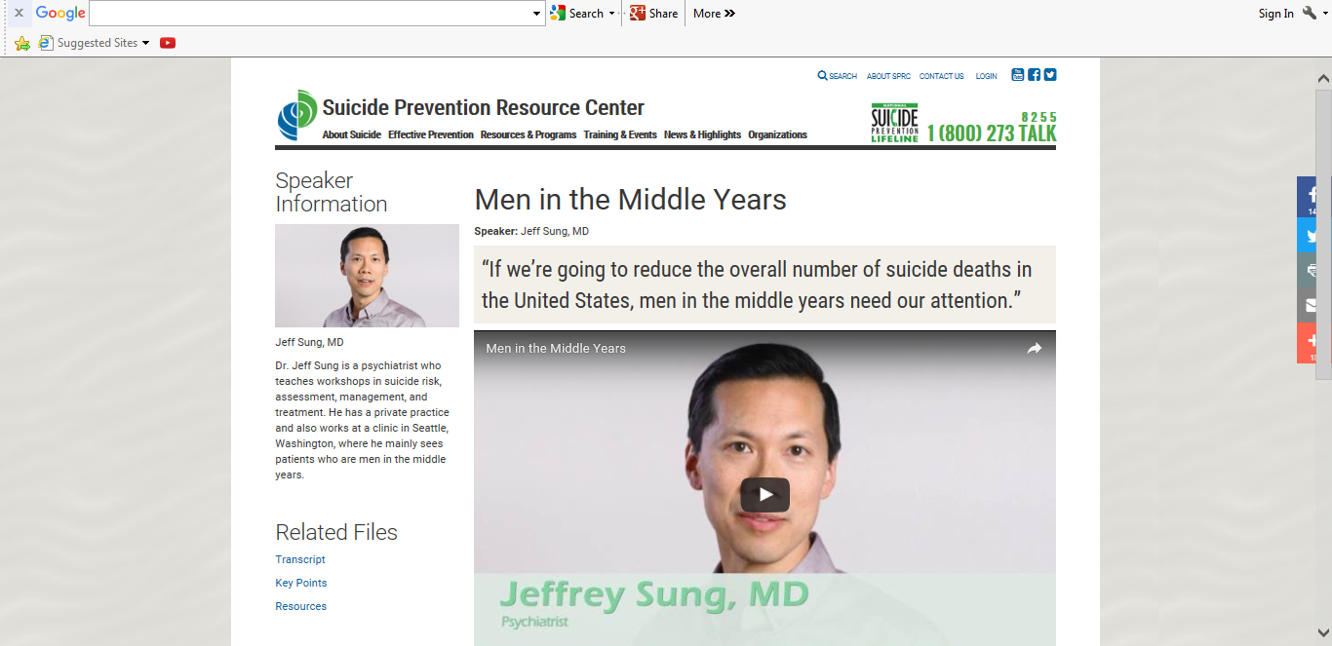

- This Web Exercise focuses upon suicide prevention and risk for our veterans in our communities. Please view Robert’s story of trauma experience, resiliency and survival.

Robert was a young medic whose experiences witnessing death and treating severe combat wounds made him face the hard truth that he couldn’t save everyone. The guilt and stress of his experiences led him to drugs and attempts to end his own life. Hear this powerful story of a man finding the strength and resolve to get help and get back on track.

For Robert, discuss how the significance of social support, family, and his spiritual life helped him to not give up on hope and to live well.

http://maketheconnection.net/stories/7

Though the example above is provided for this exercise. Please share the following with friends and family of veterans who may find the following resource helpful.
http://maketheconnection.net/stories-of-connection

- This Web Exercise focuses on ECT as a therapeutic intervention for depression.

View examples of ECT https://www.youtube.com/watch?v=-T0mwzXHgvI

From the link above: Depression is a very common and highly disabling medical condition. Severe depression can be deadly, resulting in suicide and increased mortality from other illnesses. Although medications and psychotherapy are effective treatments for many patients with depression, treatment-resistant depression (TRD) affects millions of patients worldwide. Electroconvulsive therapy (ECT) remains the most effective treatment for severe depression and TRD. This video provides an introduction to ECT for patients, family members and clinicians that may be considering this treatment option.

After viewing this video clip from Dartmouth-Hitchcock Medical Center, in what ways did your attitudes regarding ECT as a form of treatment for depression change?

