Chapter 5: AN OVERVIEW OF PSYCHOPATHOLOGY AND CHANGING CONCEPTUALIZATIONS OF MENTAL ILLNESS
- This Web Exercise focuses upon identifying current research supported by NIHM Child and Adolescent Mental Health.

Visit and explore the following NIMH webpage. Identify links and topics that you find interesting or learning more about in regards to childhood-based disorders and briefly summarize what you found to be particularly helpful about the information and/or the content of the links.

https://www.nimh.nih.gov/health/topics/child-and-adolescent-mental-health/index.shtml

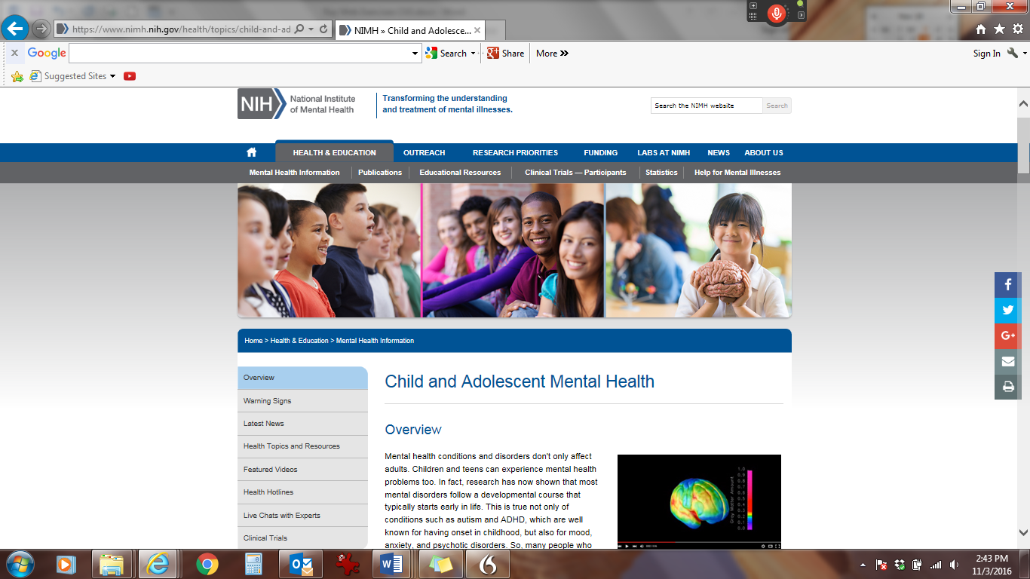

- This Web Exercise is relevant to the topic of mental illness, stigma, and resiliency.
View the 60 Minutes video: The stigma of raising a mentally ill child. Discuss the challenges associated with having a child with mental illness in regards to stigma and available resources. What do you think to be the greatest challenges for families in seeking services for their children?

https://www.youtube.com/watch?v=nlCPlrULSGA
60 Minutes

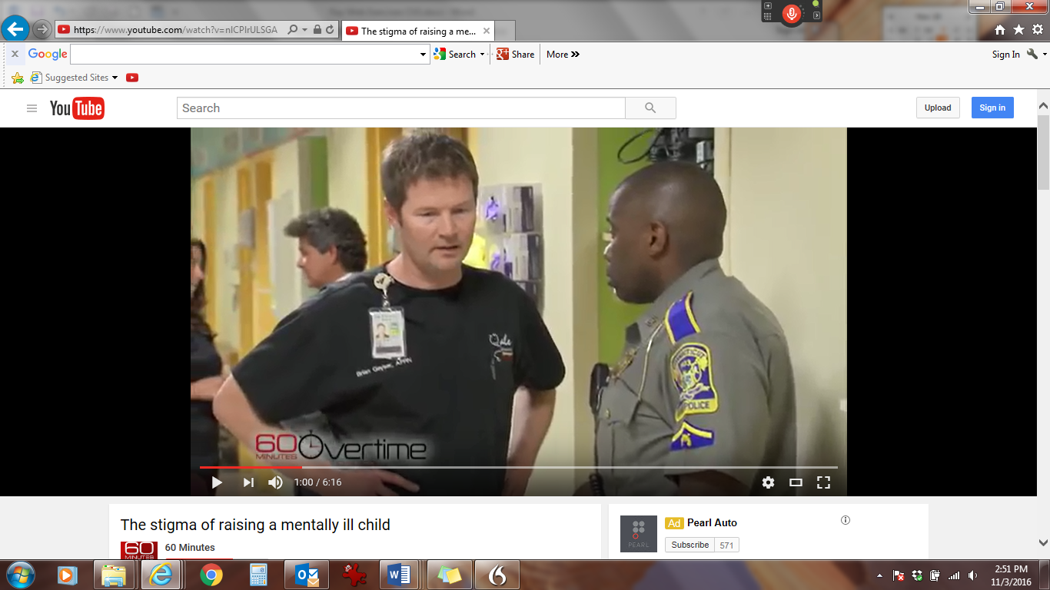

- This Web Exercise is relevant to the topic of mental illness symptoms, stigma, and resiliency and the significant role of the family and community in helping youth and young adults live with this challenging mental illness.

View the Adolescent Onset Schizophrenia -- Keeping Kids Healthy video link below. Discuss the challenges associated with having a child with mental illness in regards to stigma and available resources. What do you think to be the greatest challenges for families experience in seeking services for their children? Describe how development of identity is disrupted as well as the significance of resiliency.
Adolescent Onset Schizophrenia -- Keeping Kids Healthy
Susankkh
https://www.youtube.com/watch?v=wD8O9iHWb2E

