Chapter 2 NEUROSCIENCE APPROACHES TO UNDERSTANDING PSYCHOPATHOLOGY
- This Web Exercise focuses upon current research on neuroplasticity and learning; and how these research topics relate to resiliency, intervention, and recovery of brain injury.

Visit and view the following link:
https://www.youtube.com/watch?v=LNHBMFCzznE

Published on Dec 15, 2015
In a classic research-based TEDx Talk, Dr. Lara Boyd describes how neuroplasticity gives you the power to shape the brain you want. Recorded at TEDxVancouver at Rogers Arena on November 14, 2015.

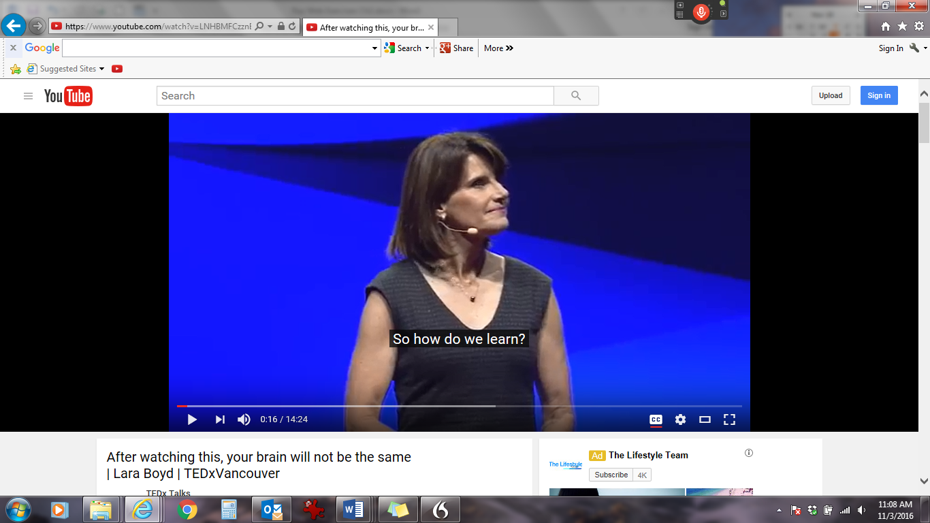

- This Web Exercise is relevant to the topic of brain, neuroscience and psychopathology.

Please visit Dr. Chudler’s link and explore the topics of your interest and relevant to neuroscience and psychopathology. Describe how useful the webpage is increasing knowledge and understanding regarding brain functioning by highlighting and describing a link (or two) from the page below. What in particular did you find helpful regarding this site? Be sure to reference the relevant subheading areas from the Ray text when discussing your response.

http://faculty.washington.edu/chudler/introb.html#bb

The link below describes some of Dr. Chudler’s training and experience as well as the team that provides the resources for the webpage: http://faculty.washington.edu/chudler/whowe.html

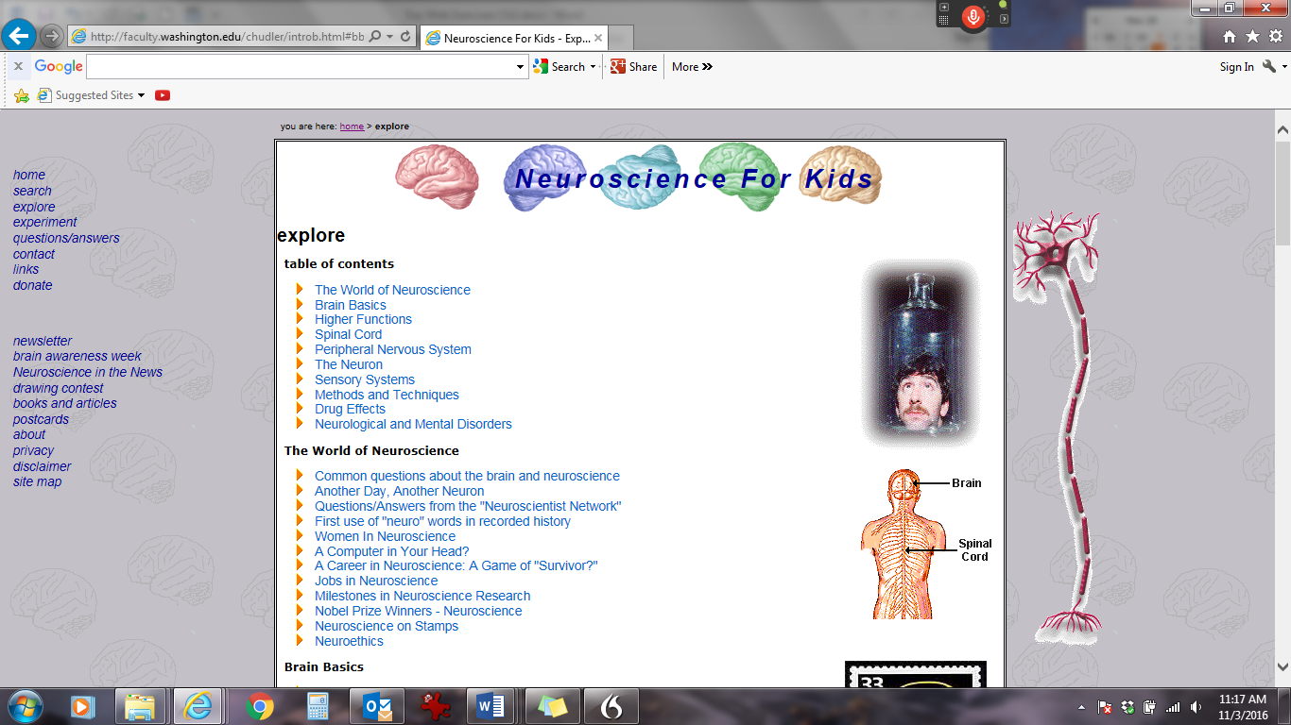

- This Web Exercise is relevant to the chapter section: ethics, genetics, and epigenetics.

View the video clip from the National Institutes of Health Human Genome Research Institute: Ethical, Legal and Social Implications (ELSI) of Genetic Knowledge. In what ways did the video increase your knowledge regarding the complexities of Human Genome Research? Scroll down and respond to one of the discussions associated with ELSI Vignettes and Discussion Material:

•Guidance for ELSI Vignettes
•Nature vs. Nurture in the Criminal Justice System
•Duty to Warn
•Access by Law Enforcement
•Interpreting Risk: The Impact of Life Experiences
•Genetic Screening and Discrimination: Relevance of Historical Experience
•Genetic Discrimination: Inherited vs. Acquired Disease
•Genetic Determinism: Endurance Athletes
•Genetic Testing: Protecting Health or Denying Rights?
•One for the Other
•The Benefits of Research: Do We Share the Wealth?

