Chapter 1: AN OVERVIEW OF PSYCHOPATHOLOGY AND

CHANGING CONCEPTUALIZATIONS OF MENTAL ILLNESS

Web Exercises
- This Web Exercise focuses upon identifying current research supported by NIHM and how these research topics relate to the three approaches of psychopathology.

Visit and navigate the NIMH site, explore its content. Carefully review: RESEARCH PRIORITIES, from the menu bar. What are the key areas of research NIMH is focusing upon regarding mental health and illness? Describe how these studies relate to the three approaches to psychopathology: psychodynamic, existential-humanistic, and the cognitive behavioral.

https://www.nimh.nih.gov/index.shtml

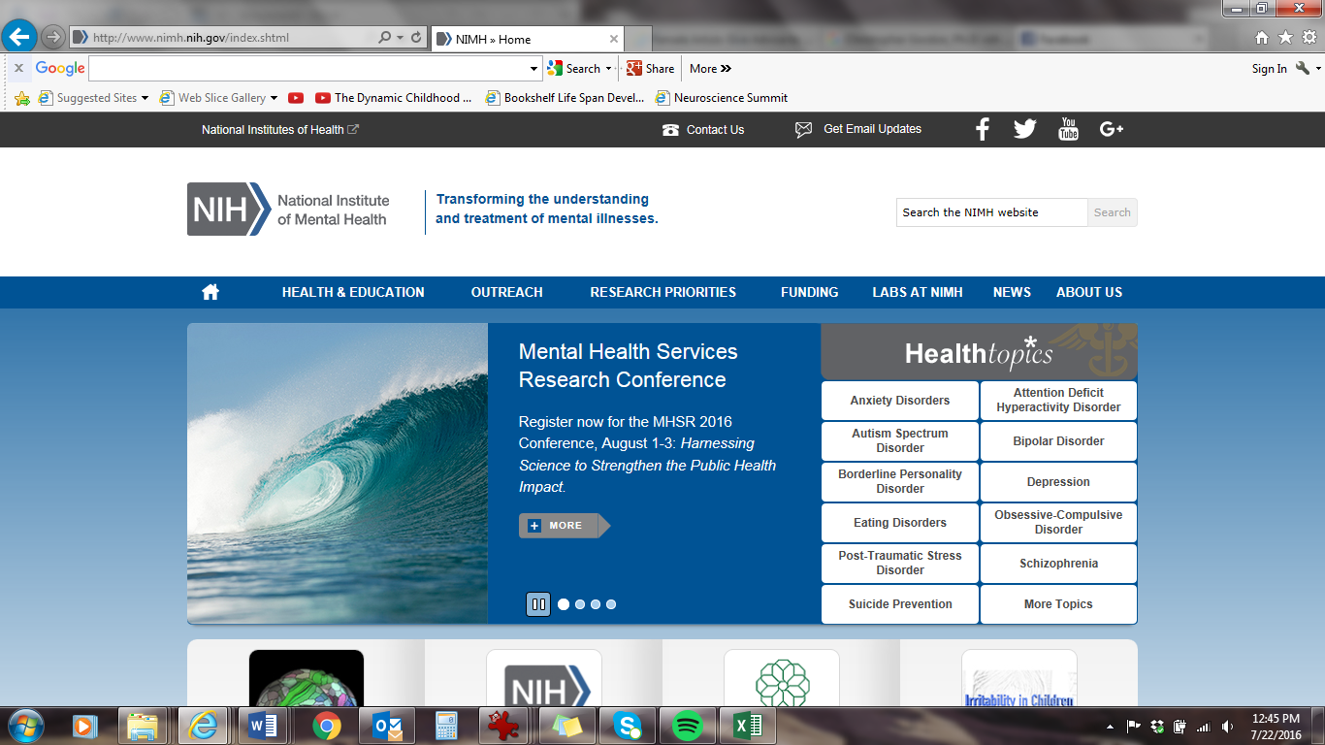

- This Web Exercise is relevant to the topic of mental illness, stigma, and resiliency.

Please view the following TED talk by Elyn Saks: A Tale of Mental Illness – From the Inside
https://www.ted.com/talks/elyn_saks_seeing_mental_illness?language=en
Describe how Dr. Saks’ TED talk helps to reduce the stigma associated with living a full life with a mental illness. Also, provide examples from her talk highlighting social support, qualities and characteristics, and resiliency that will assist someone contending with challenging or difficult times in a person’s life.

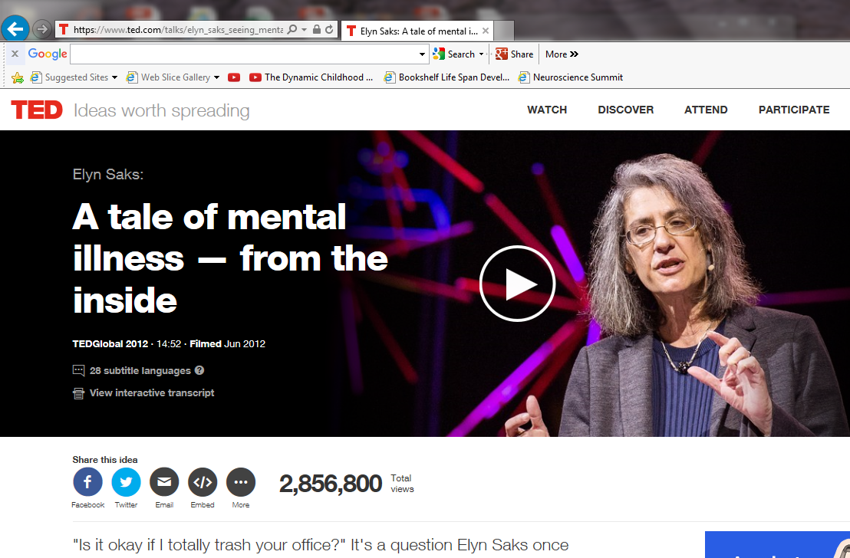

- This Web Exercise is relevant to the chapter section: Psychological Treatment Perspectives in the 20th Century

Select two major contributors to mental health treatment/research from the following as noted in chapter 1:
- Sigmund Freud
- Hans Strupp
- Carl Rogers
- Abraham Maslow
- Leslie (Les) Greenberg
- B. F. Skinner
- Albert Bandura
- Aaron Beck

Using the following weblink: https://en.wikipedia.org/wiki/Portal:Psychology

Look up these two renowned contributors from the link above. Compare and contrast the content from your searches with the chapter 1 content, briefly highlighting the researcher’s/theorist’s contribution in relation to treatment and mental health services. Likewise, identify and describe an interesting aspect about the contributors that you learned about as a result of reviewing the web resource (and associated links) from Wikipedia, the free encyclopedia, Psychology Portal.

