Needs Assessment Primary Example: Student Copy

Student Needs Survey (Grades 1–3)
1. | Y or N
2. 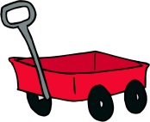 | Y or N
3. | Y or N
4. 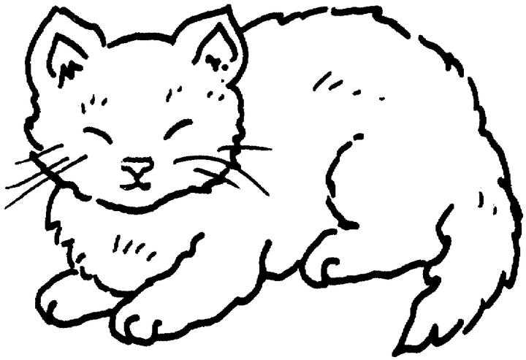 | Y or N
5. | Y or N
6. 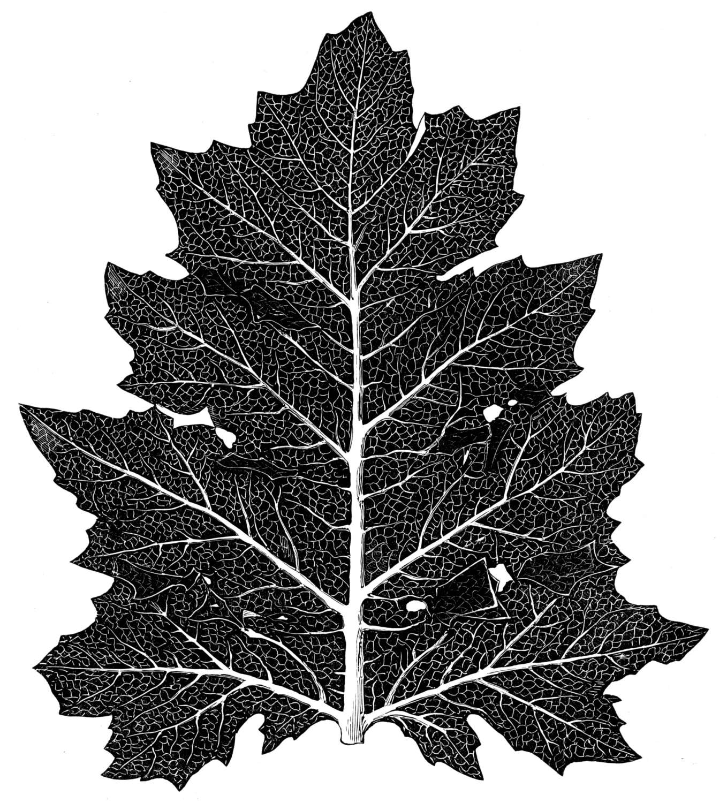 | Y or N
7. 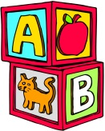 | Y or N
8. | Y or N
Images courtesy of clipart.com.
Retrieved from the companion website for Facilitating Evidence-Based, Data-Driven School Counseling: A Manual for Practice by Brett Zyromski and Melissa A. Mariani. Thousand Oaks, CA: Corwin, www.corwin.com. Reproduction authorized only for the local school site or nonprofit organization that has purchased this book.

